Creating and Conducting Surveys in Multiple Languages

With the SurveyPocket app version 5.9 there is a new feature that makes it easier to conduct surveys in multiple languages. All questions are kept in one clean, easy to read way survey eliminating the need for multiple surveys, skip logics, or crowded text. And all data, regardless of the language used, will be available in a single dataset in the survey’s analytics tab.

First, you’ll need to create the language version(s) of your survey because SurveyPocket does not automatically translate surveys for you. Do this in a program like Microsoft Word so you can cut and paste the text into SurveyAnalytics later. If you need help with translation, we recommend collaborating with other tobacco projects by sharing Folders in SurveyAnalytics.com.

Once you’ve entered the survey in English, you can add other translations to that same survey. Here are the steps to create a multiple language survey in your SurveyAnalytics.com account.
- Select your survey from the “Surveys” tab
- Select “Settings” from the section on the left side of the screen
- Scroll the page down to the section labeled “Language”
- Select “Add Language Version”

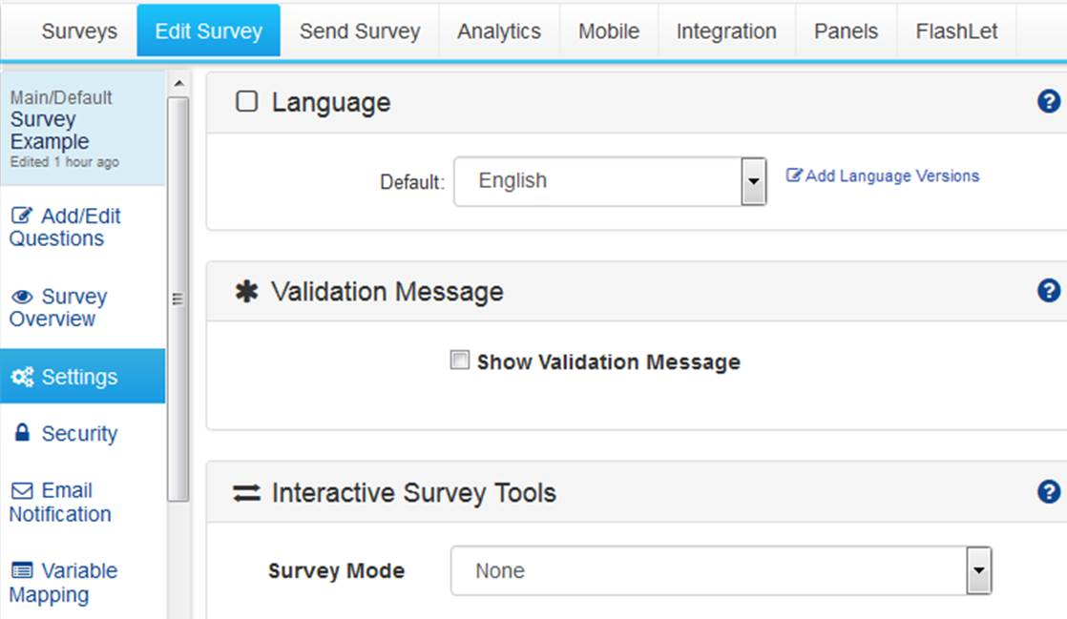
2
3
4
- Select the desired language from the menu
- Select “Add Language Version”
- Scroll to the bottom of the page and select “Save Changes”

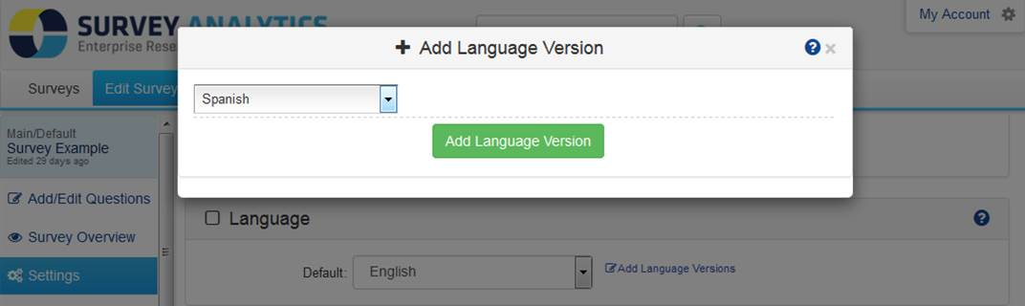
6
5

- Select “Edit Surveys,” the tab along the menu tab at the top (second tab from the left)
- Select “Edit” on the questions to be translated (move the mouse over the question)
8
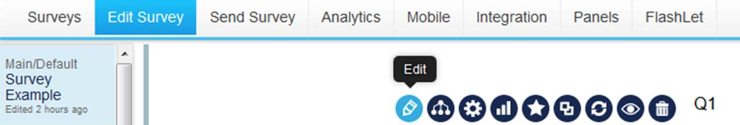
9

- Select “Language Version” from the menu left of the text box
- Enter the question and answer choices translations in the boxes to the right of the text
- Select “Save Question”
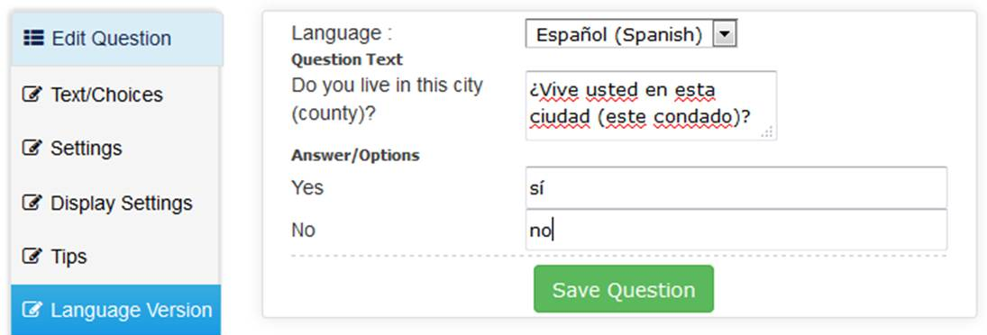
10
12

11

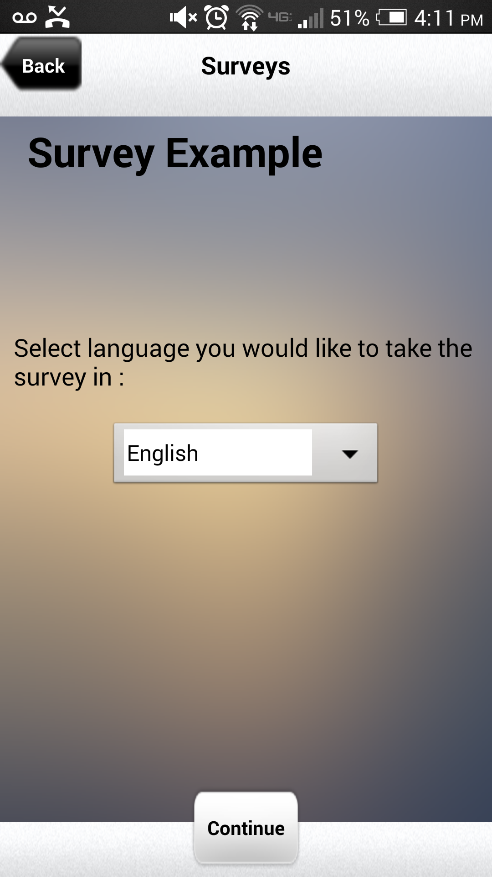
Repeat steps 8-12 for every question and answer choice in the survey. And repeat this whole process for every language in which you want to conduct the survey.

When it comes time to taking the survey on a handheld device, ensure that the device is loaded with the SurveyPocket app version 5.9 or higher. This feature is not supported on older versions of the app.

Once you select your survey, the first question will prompt, “Select language you would like to take the survey in :”

Indicate the language, and the survey questions and answer choices will be displayed in the selected language

© 2014. California Department of Public Health. Funded under contract #12-10499.

