Highlights
When communicating results to the other stakeholders—such as the local community, partner agencies or busy policymakers, consider condensing key points to a one page document that features key findings broken into digestible chunks of information. Instead of making recommendations, specify desired actions or next steps.

Pursuing Tobacco Retail Licensing in Antelope County
Report Highlights June 2017
In order to limit youth access to tobacco and electronic smoking device products and marketing, the Antelope County Tobacco Control Program worked on getting at least two local cities to adopt and implement a Tobacco Retail Licensing (TRL) policy by June 30, 2017. The policies were to earmark a portion of the license fee for enforcement activities and restrict exterior signs and advertising to no more than 15% of the window and clear door area.

There are 160 retailers in the county that sell tobacco or vape products. Many of those products are designed to appeal to youth.

Significant Data Points

% of Antelope County retailers were caught
17
selling tobacco products to minors compared to 9% across the state

% of stores in target cities had twice as much
85
exterior signage and ads than state law allows

% Increase in the number of stores selling vape
77
devices/e-cigarettes in the last three years

% of youth in Antelope County uses tobacco
24
products but only 7.7% statewide do

% of respondents favor tobacco retail licensing
70

tobaccoeval.ucdavis.edu
Key Findings
Illegal sales of tobacco products to youth is a problem in our county. Despite CA’s STAKE Act law, 17% of Antelope’s retailers were caught selling products to minors in 2013.
Parents are concerned about youth access and exposure to tobacco products and advertising.
Storefronts promote unhealthy products by covering more than 33% of window/clear door space with exterior advertisements and signage, breaking the state-mandated Lee law.
Some retailers are in favor of a licensing policy, but without enforcement those who follow the law are at a disadvantage.
Law enforcement is supportive of the measure but worry monitoring duties would detract from priority focus on crime.

Call to Action
More than 170 cities and counties throughout California have a tobacco retail licensing policy. It’s time that Antelope County communities get the same protection.
Pay attention to how the tobacco industry is targeting young people with its products and marketing. Take photos of ads in your neighborhood that kids view on a daily basis in local stores.
If you don’t like what you see, ask retailers to stop carrying and promoting harmful products aimed at youth.
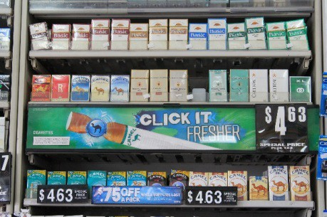
Policymakers find it harder to say no to youth than to adult constituents. Train youth to be spokespersons at city council meetings and ask policymakers to pass a tobacco licensing law.

In April 2017, Savannah became the first city in the county to adopt a tobacco licensing policy. We hope this trend continues in the next three years as other cities consider doing the same.

29

