Slopegraphs

Hello Slopegraphs!
Slopegraphs are a blast! This newer graph type is really great at showing change between two points. It works especially well to show the story of how one thing decreased when everything else went up. Or how one thing went up at a pace faster than all else.
Because this is a newer graph type, it’s still flexible in how people execute it. I’ve used it to show change between pre and posttests. I’ve used it to compare beginning of the year to end of the year test scores. I’ve seen other people use it to compare categories, like boys and girls. The research article here by Zacks and Tversky suggests that people read lines as trend lines (over time) so be careful applying the slopegraph to things that are just categories but feel free to test it out there too.
Usually the lines in the slopegraph are labeled directly, so check out the post on embedding legends for a refresher.
If you have a situation where the labels are overlapping each other, it could be a good idea to color code the label to match the line and then just drag one label slightly up or down so they don’t overlap anymore. But if Excel adds what it calls leader lines, connecting the nudged label and the line, delete it.
Upload your slopegraphs in the comments section below to show off or get feedback!

Member Spotlight
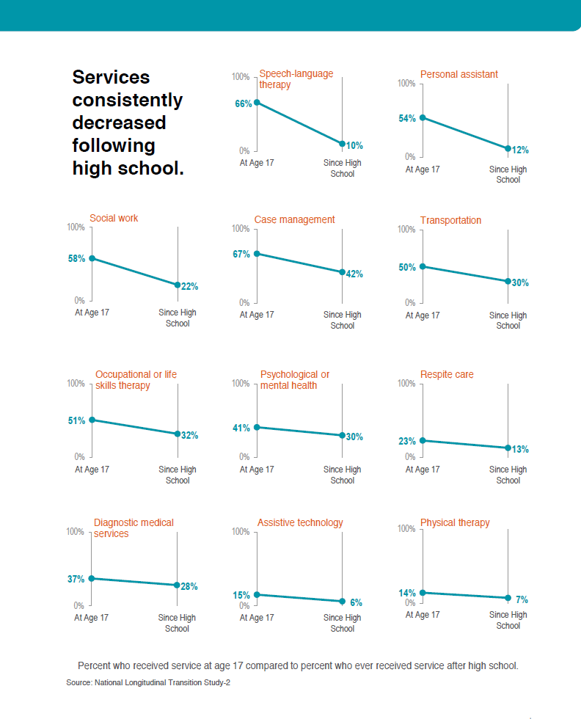Slopegraphs in action!
The page full of slopegraphs came from a report made by Drexel University (I was the data visualization consultant). The set of slopegraphs are arranged from most to least change, making this data even easier to read. Check out the full report.

In the Wild
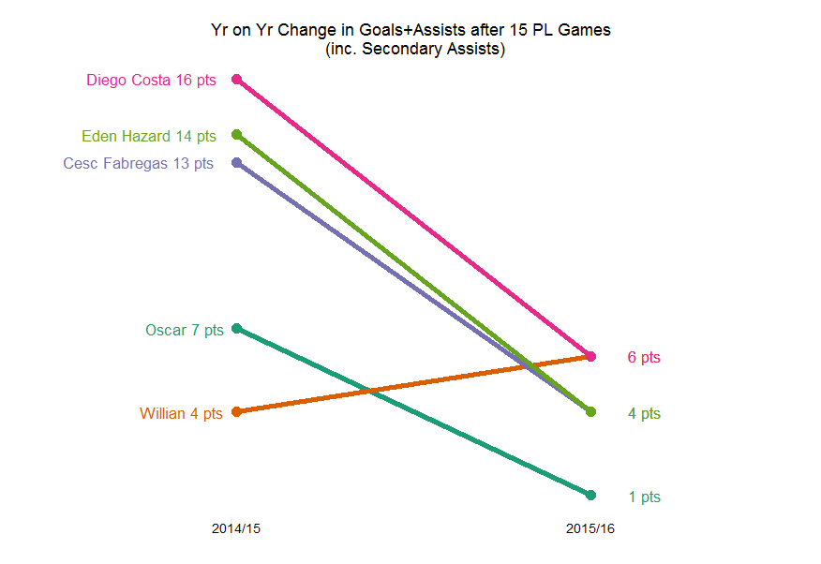via Andrew Clark
Color code the labels to the lines as needed. And consider, like in this example, using just one label if two lines converge at the same point.
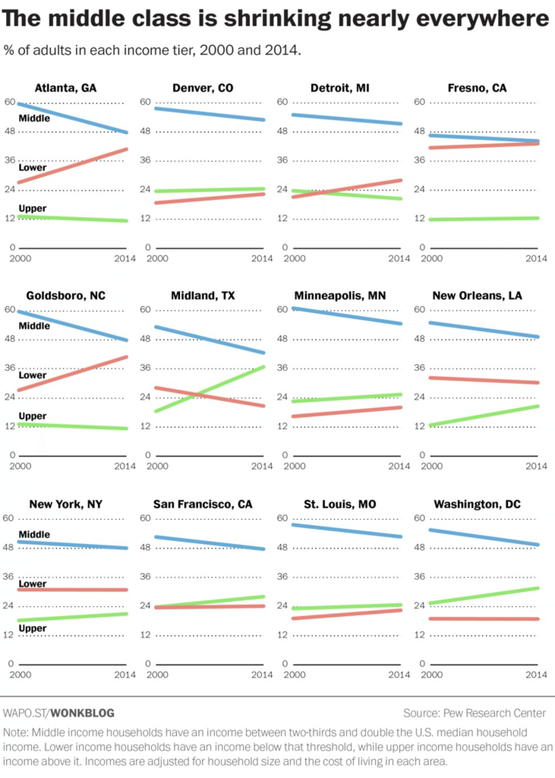from the Washington Post
Slopegraphs as a set of small multiples! Cool. In this case, you can just label one graph and be consistent in color coding throughout. Note here that they didn’t label each line with it’s values, but used a y axis on the left.
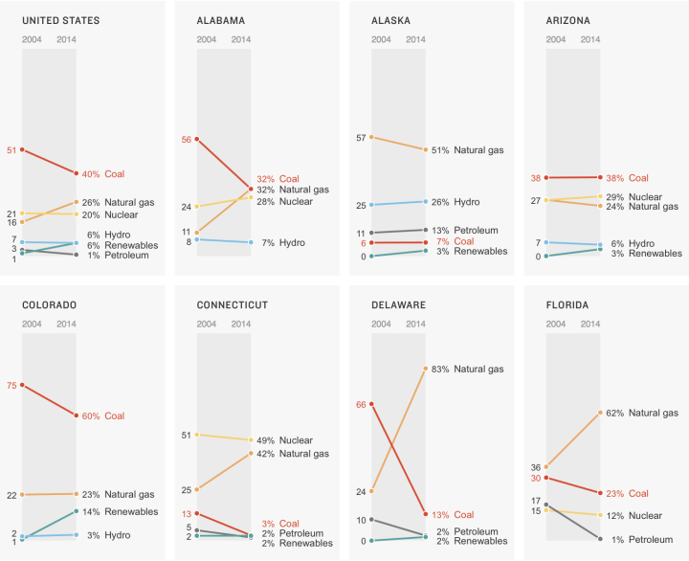from NPR
Another example of slopes in a small multiples arrangement. You can always add markers to either end of your line if you like the look of it. This example is also a nice one to ask whether the axis needs to go to 100%. It’s something I’m sure you wondered when working through our example. What do you think?

The Written Instructions
Let’s say we are comparing sales in each department of a grocery store, before and after they moved locations. As a side by side bar graph, it would look like this:
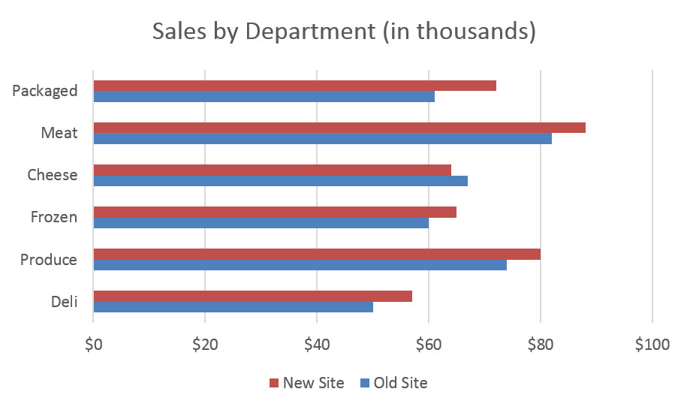
Even though humans are good at detecting length, this graph is somewhat difficult to digest. It’s a bit hard to see that sales of cheese are actually down at the new site, for example. It’s easy to miss that just one New Site bar is shorter than its corresponding Old Site bar. A slopegraph will make the story clear.
The table for a slopegraph is probably quite familiar: just two columns of numbers.
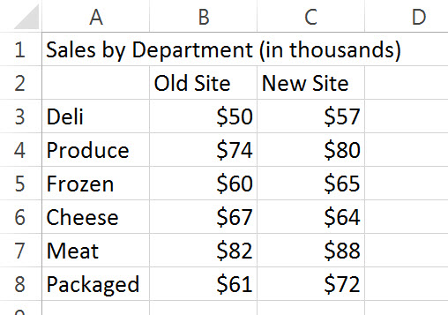
You will highlight the rows and columns and insert a line graph. I prefer a line graph with markers, but maybe I’m just obsessed with dots.
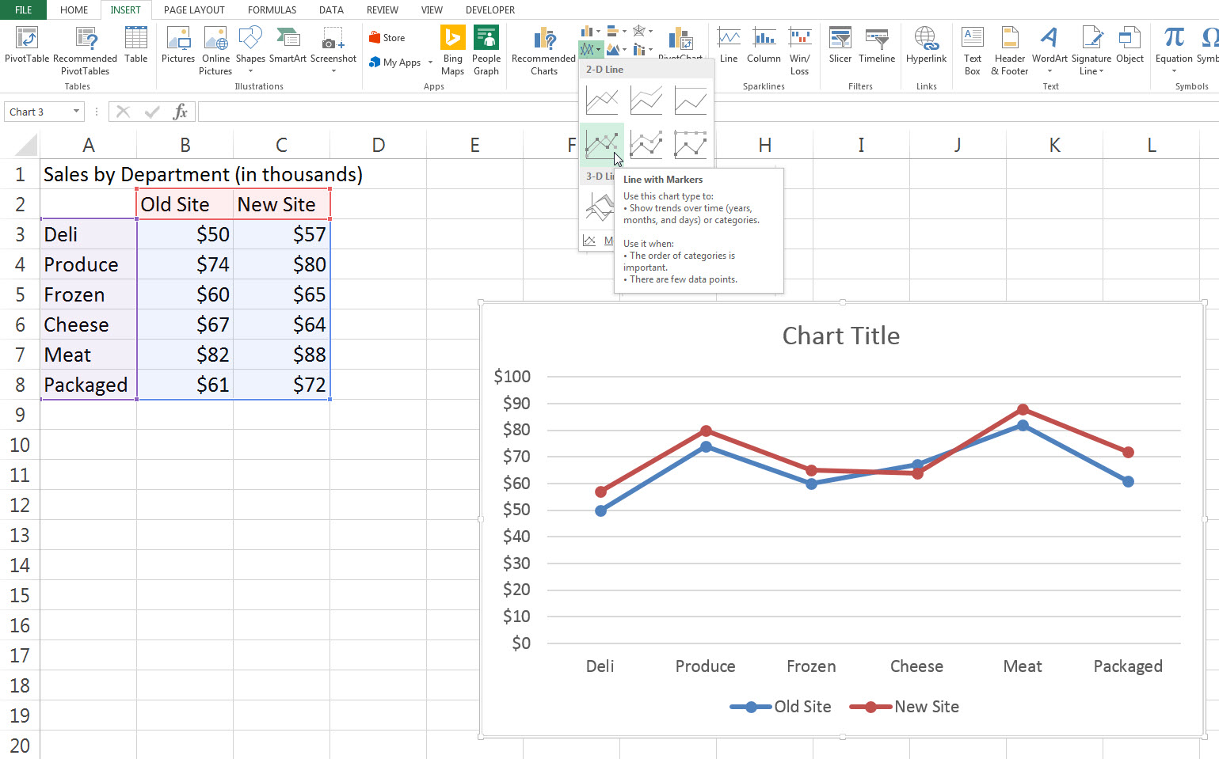
It doesn’t quite look right – the departments are on the x-axis and they shouldn’t be. Click your old friend Switch Row/Column.
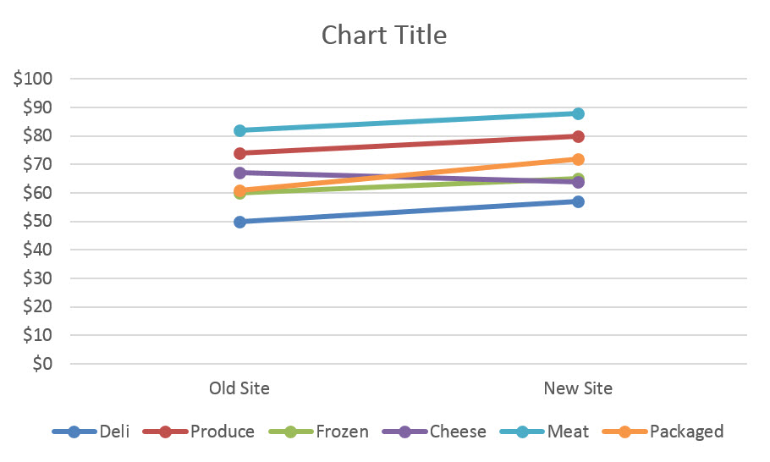
You can see the beginnings of the slopegraph in this modified line graph already. The differences are minor but interpretively important. Slopegraphs usually have no space between the end of the line and the end of the plot area. The lines are pushed to either side of the graph. To delete that gap, we are going to click a single magic button inside Excel. Really, this is pretty much where it all happens.
Right-click on the x-axis and select Format Axis from that menu. In the Format Axis box that opens, look for the area with the heading Axis position. Under that, pick the radio button next to On tick marks.
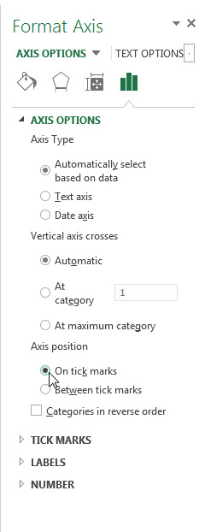
By default, Between tick marks is selected but On tick marks will push the lines to the edges of the graph.
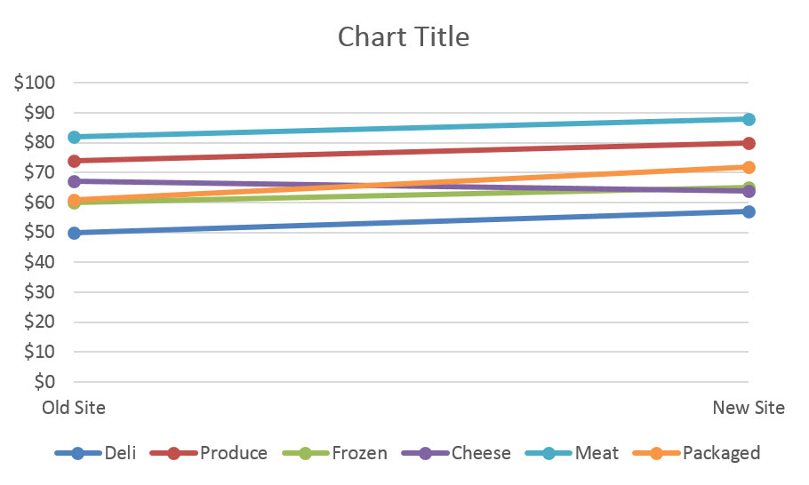
From here on out, it’s all formatting baby!
Slopegraphs tend to be long and narrow, unlike line graphs, which are usually wide and short. So resize the graph by stretching the corners. This also puts some distance between points that are nearly on top of one another.
We also need some space on either side of the line to add labels. Currently, there’s a y-axis there. Delete the y-axis (just click on the numbers and hit the Delete key). Do the same for the y-axis gridlines. That buys a little bit of room on the left, but not enough. So click inside the plot area – the white space in the middle of the graph – and drag it’s side handles in on both sides. The graph space will narrow but the overall chart area will stay the same.
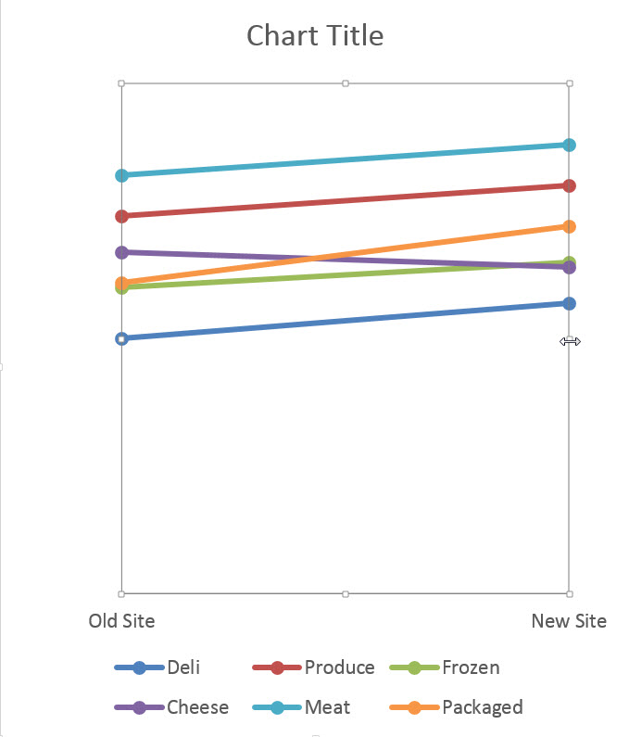
At this point, it should already be really obvious that one line is going down. We can also see that another line is increasing moreso than the others. Slopegraphs highlight this story better than any other chart type. As we continue to format the chart, we will use action colors on those two lines to bring attention to them and the other lines will go gray.
Now it’s time to delete the legend and label each point of the line. With the slopegraph, line labelling is a little tedious. You can only add labels to one line at a time. Also, I like to add the label to one side and just the number to the other, so there are a lot of clicks involved. Here’s the most streamlined way to do it and we will alter the colors in the process.
Right click on the top line and select Format Data Series. In the box that opens up, change the line color, marker fill color, and marker border color all to a medium-light shade of gray.
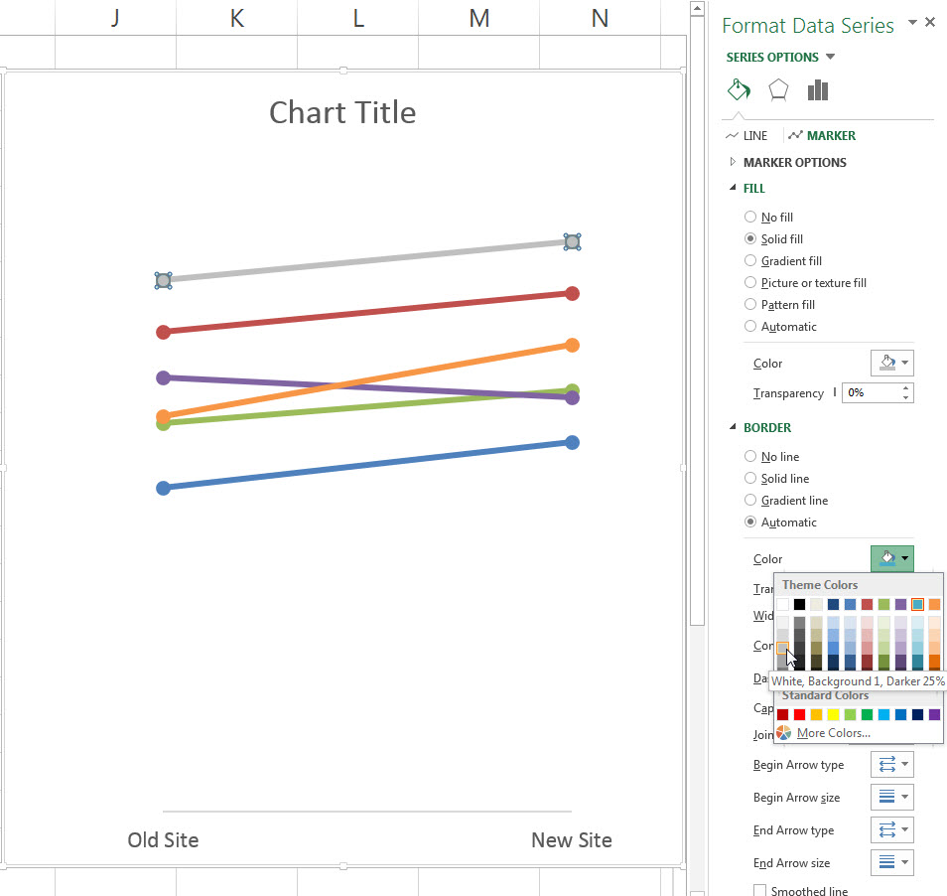
The line should still be highlighted inside your graph. Right-click on it and select Add Data Labels. This will add the dollar values to both markers. Click on the labels and change their color to match the lines. With those labels highlighted, carefully click on just the left label so that it is the only one highlighted. Then right-click on that label and select Format Data Label (it should be singular). New box opens! Check Series Name so that the right grocery department label will be added, but only on the left. Uncheck Show Leader Lines (this will matter more later). Personally, the comma that separates the label from the value offends me. In the Separator drop down menu, pick the option that says (space). Then look for the Label Position choices and pick Left.
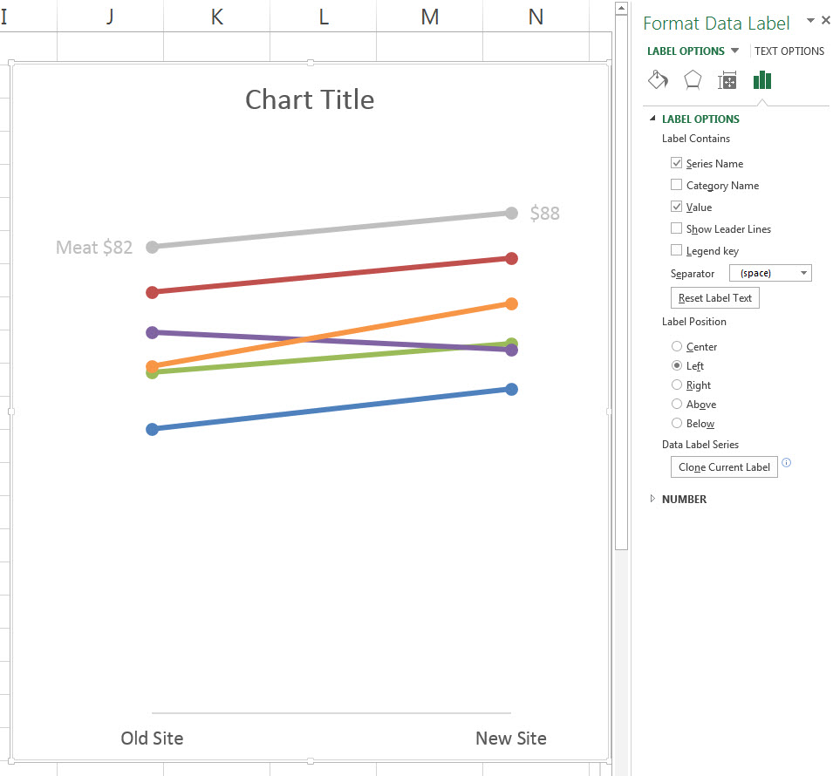
Yes, lots of steps there but the payoff is clear labeling and smart color coding that support the story inside this data. Repeat this process for the rest of the lines, choosing a medium dark color for the rapidly increasing line and a dark color for the decreasing line.
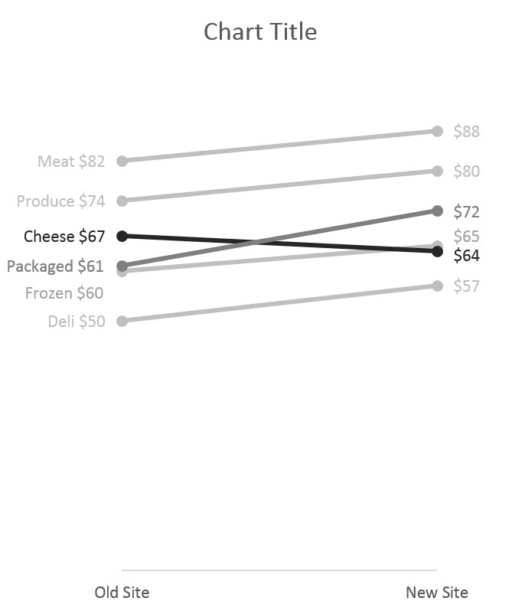
As you labeled these lines you probably noticed that the labels for Packaged and Frozen were overlapping each other. To fix that, just click on each label and drag it up or down a little to space them apart. This is why we unchecked Show Leader Lines earlier. With that box checked, each label would have an ugly, cluttering little line tying it to its part of the slopegraph.
Its ok add a great title and stop here. I like to add a final touch by inserting vertical lines that shoot up from Old Site and New Site. Right-click on the x-axis and in that menu, select Add Major Gridlines. BOOM! I also delete the x-axis line. To do so, right click on the x-axis again and select Format Axis. In the new box, look for the line color area and select no line.
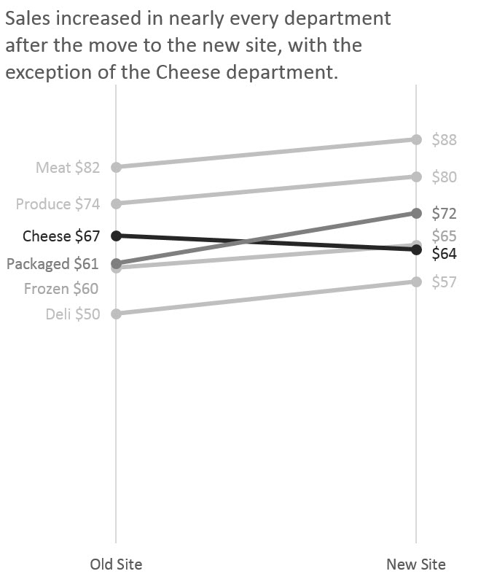
The slope of the slopegraph markedly accentuates increases and decreases when comparing two sets of numbers. Show me yours in the comments below!
Tags: How two or more numbers are alike or not, How things changed over time

26 comments on “Slopegraph”
hslover on June 13th, 2018 - 5:06pm
Hello, I was wondering if there was a way for me to present these 3 pieces of information in the same graph rather than 2 side by side, given the differences in the axes? I did have to make the labels anonymous, hence the ABC names.
Any other suggestions for improvement?
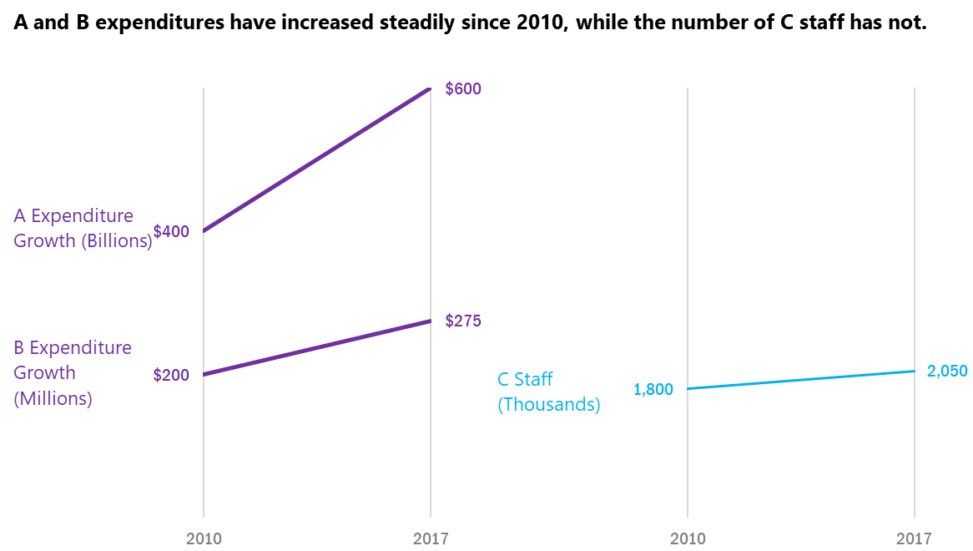
Reply
hslover on June 13th, 2018 - 5:11pm
I should provide further clarification.
The point of the graph is to show that the number of staff is not increasing at a rapid enough rate to be able to keep up with oversight of the increasing expenditures.
The scale for the left slope graph is 0-600 and the scale for the right graph is 0-6,000. I thought that would be okay since the ratio of the scales is the same, but maybe that is inappropriate?
Reply
Stephanie Evergreen on June 13th, 2018 - 6:55pm
I don’t think you can put these in the same graph, due to their scales. If you wanted to put all variables in the same graph, you could try converting it to % increase since 2010 and then everything would be just in a bar chart.
Good question about the scale on the staff graph. I see your reasoning, completely, but do think it would easy for detractors to say that you could change the scale and the rate would look as big if not bigger. Converting all of these metrics to the same variable makes your argument more bulletproof. You can do both, actually. Have these slopegraphs as they are and then add a bar of % change on the side.
Reply
Priscilla Sanchez on June 8th, 2018 - 1:57pm
Is the slopegraph a bad idea for when I have 2 series that have the exact same values? This will show up as one line, and I am having a hard time selecting one of the lines. See my draft chart below. Conduct and Attachment have the same pre and post values (but you can’t see Attachment).
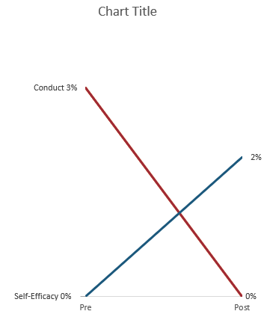
Reply
jrlyons on June 8th, 2018 - 4:33pm
I see exactly what you mean. In this case, I would not use a slope graph. What about overlapping bar charts or small multiple bars? I think one of those chart types could work for your data.
Reply
Priscilla Sanchez on June 13th, 2018 - 5:28pm
Thank you for your feedback. I think the overlapping bar chart might not work either as it looks funny when 0% is in both pre and post values for different categories. (See image.) I’m thinking about how to present data with small multiples since the template in the website has 3 options (Yes, Sorta, No) that seem to add up to 100, while I only have 2 “options” (Pre and Post) which wouldn’t add up to 100. Hmm.
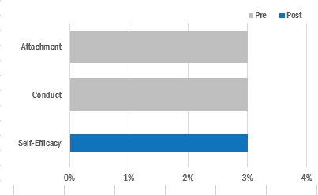
Reply
wking on January 12th, 2018 - 3:33pm
Does anyone have advice for how many cases (generally) can be effectively shown on a slope graph before it’s too cluttered?
Reply
Stephanie Evergreen on January 15th, 2018 - 9:45am
I haven’t seen any specific rules. But I do think that controlling the color can help reduce clutter, like in the example here: https://www.ft.com/content/7962a888-c076-11e7-b8a3-38a6e068f464
Reply
thompsc on December 19th, 2016 - 12:49pm
I was looking at the example in the member spotlight and it seemed like a good use of a slopegraph to me, however I was trying to brainstorm alternatives that could be a bit more telling (depending on the message they are trying to portray). One of the things I came up with was a waterfall chart (shown below). Although, it is nice to see which categories of services that declined after high school, in some instances it is nice to be able to make temporal comparisons. For instance, in my example you can see that the largest decreases were for services utilized by a vast majority of 17-year old students. You can also see this in the Member Spotlight example, but due to the arrangement of the charts it is a bit more difficult. In my example it is a bit tricky to compare the magnitude of the differences due to the differences in position of the bars vertically on the graph, but that’s also where the percentage labels come in (and the fact that it is arranged in descending order helps a bit). What are peoples’ thoughts/opinions on the use of waterfall charts?
Reply
thompsc on December 20th, 2016 - 1:40pm
Here is the graph I was referring to in my example.
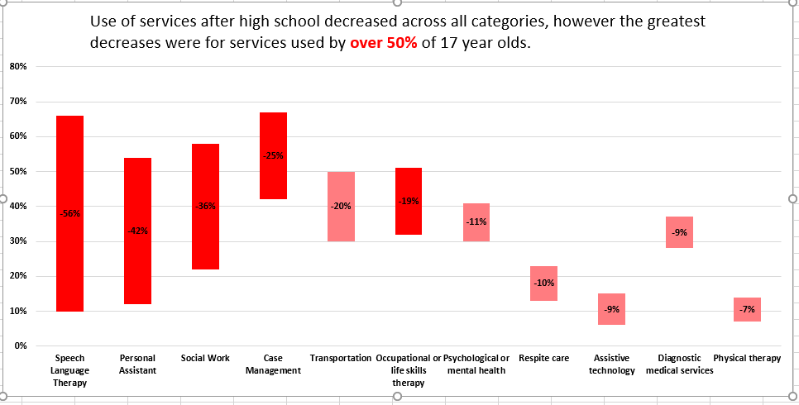
Reply
Stephanie Evergreen on January 15th, 2018 - 9:39am
It has taken me a while to warm up to waterfall charts because I think you have to know how to read them in order to read them. That said, they are very popular with certain industries, like sales, where everyone knows how to read them. We’ll have a tutorial on these in the future, but pretty easy to make, as you know. I think you pointed out the pros and cons of this versus the slopegraph. It comes down to your point – as usual.
Reply
khouston on November 18th, 2016 - 8:21pm
Question on these: I’m working on final report with baseline and followup survey data that looked at a number of mental health outcomes that are unfortunately all on different scales (e.g., 1-7, composite score 13-65). I feel like small multiples slope graphs could be the answer but am struggling with how to deal with all the different scales on the y-axis. I’m hesitant to just put everything on one scale proportionally because the original response values have meaning due to the way the scales are administered. Any suggestions?
Reply
jrlyons on November 23rd, 2016 - 5:59pm
Small multiple slope graphs sound like a great choice for your data. One idea would be to mention the scale in a subtitle for each of the graphs. Are there enough on similar scales that you could group them into smaller grouped slope graphs?
I would love to see what you come up with!
Any other suggestions?
Reply
Kylee_Truswell on November 10th, 2016 - 12:50am
I’ve also used slope graphs to show percentage change over time – same theory, just everything starts at zero.
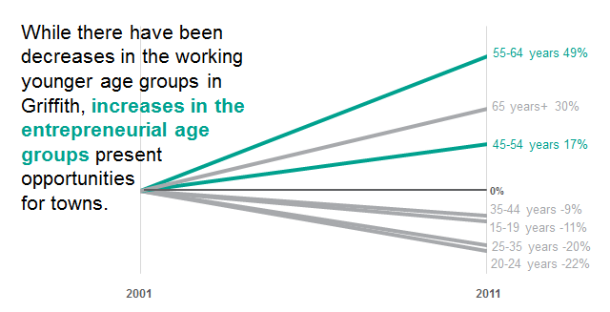
Reply
resselk on July 3rd, 2018 - 11:38am
I like this representation of a slope graph and the story it tells. Thank you for sharing Kylee, I hope to use something similar.
Reply
tanyao on October 24th, 2016 - 6:29pm
Stephanie is testing my skill development ability in so many ways! I guess lesson one is figuring out how to properly post to this list.
Reply
Stephanie Evergreen on November 3rd, 2016 - 12:39pm
Nice work, Tanya! As we discussed on the Office Hours call, you can move the labels so they are on the lines, rather than clustered on the left. Or you can add the labels to the numbers on the right, where there’s less overlap.
Reply
tanyao on October 24th, 2016 - 6:14pm
Here is my first reveal, it isn’t perfect and needs a bit of adjusting. My challenge is how to de-clutter that info in the lower left corner. Ideas? I have posted the “default” report export and my revision.
Reply
lori@thechildrenstrust.org on September 9th, 2016 - 9:51am
We used a slope graph in our strategic investment highlights to show how some but not all of our targeted outcome areas for youth programs improved.
Reply
tchoephel on September 8th, 2016 - 6:27pm
I am analyzing a project and want to show the changes in budget categories over time. I initially used two points in time – 2013 and 2015 – but then there was another milestone in 2016. Does it work to use a slope graph for three points, or is another chart type advised?
I’ve included a dummied up image of my graph. Each line is a summarized budget category, and the line colors indicate those categories that are related.
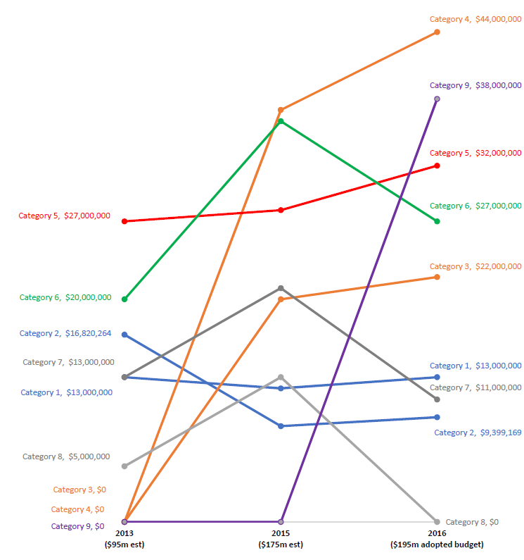
Reply
Andrew Forsman on September 21st, 2016 - 5:46pm
Maybe try the small multiples approach, with one row for the categories that grew a lot, one row for those that stayed about the same, and one for those that shrank. This could use a little cleaning up, but you get the idea.
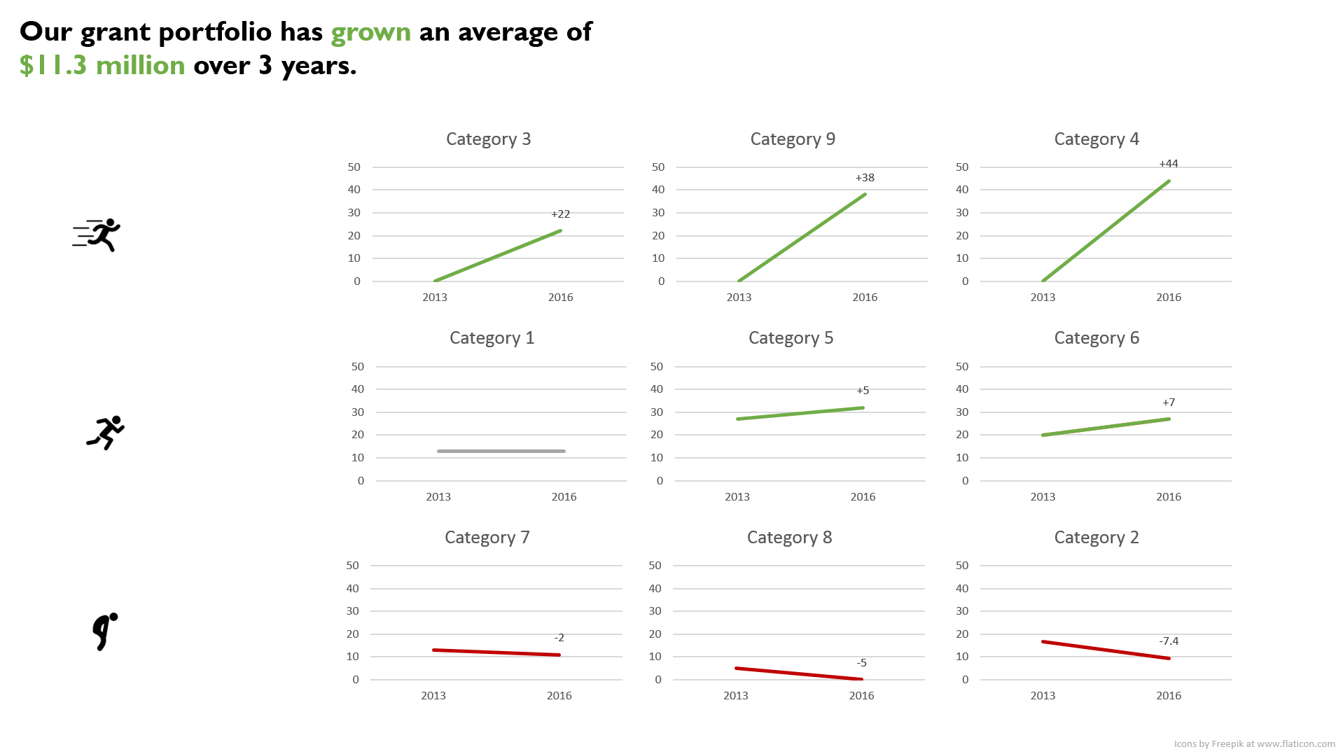
Reply
tchoephel on October 13th, 2016 - 2:21pm
Thank you for the small multiples suggestion, Andrew. We’re going to simplify the slope graph instead (e.g. use two time points, use accent colors for just a few of the categories).
Reply
Stephanie Evergreen on October 24th, 2016 - 6:19pm
Awesome. Two points in time is best for the slopegraph (otherwise it’s a line graph). And if you were going to make a line graph, Andrew’s small multiples suggestion is the way to go!
Reply
thompsc on December 19th, 2016 - 12:53pm
I would recommend small multiples, but I might consider grouping the related categories on the same graph so you might have 6 graphs instead of all 9. It really depends on the message you are trying to get across.
Reply
marthad on September 8th, 2016 - 2:46pm
I reduced the range of values on the vertical axis to make the data points wider apart and easier to view.
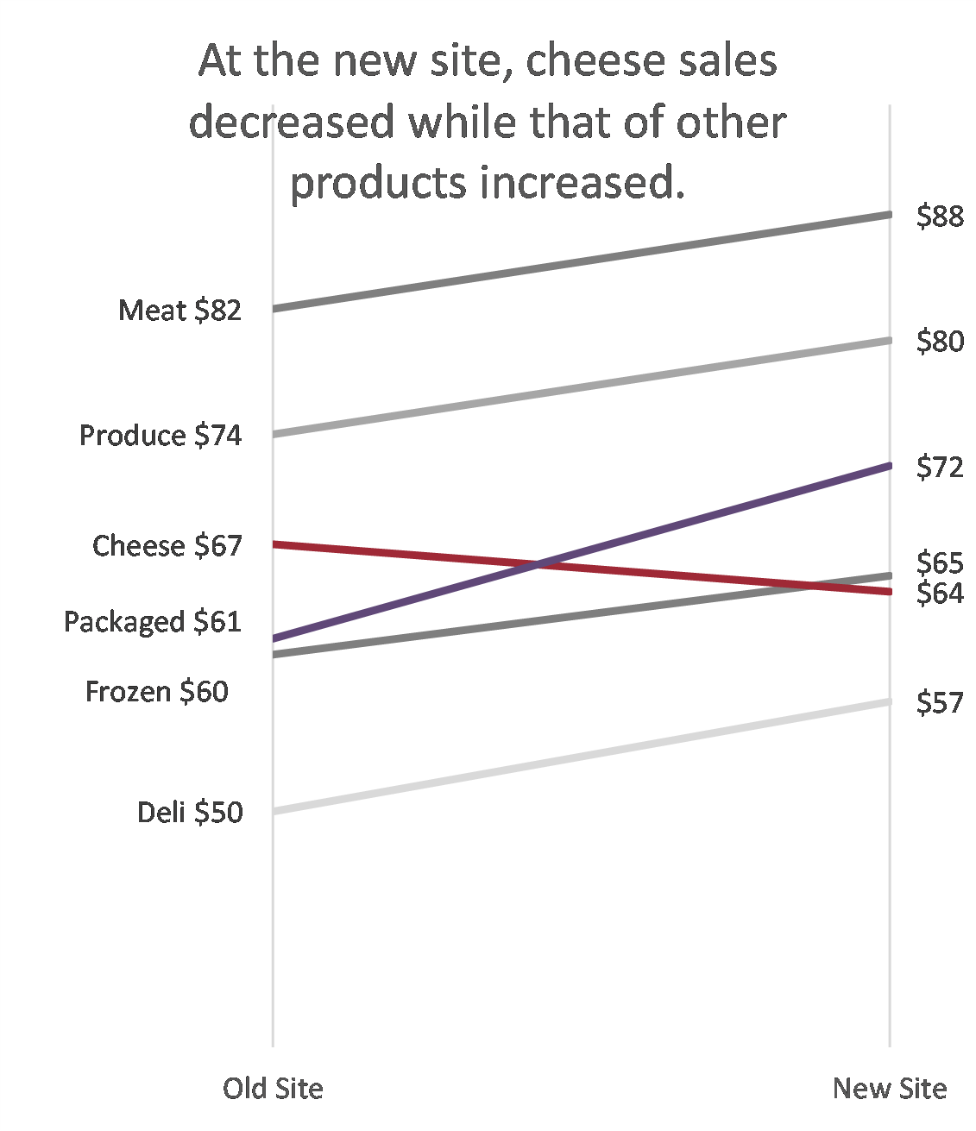
Reply
Stephanie Evergreen on October 24th, 2016 - 6:17pm
I think this is a fine idea but you might want to label your axis, at least the start and end, or else someone is likely to point out that you didn’t start at zero and whoa man is that a debate you do not want to walk into blindly. Not to say you always have to start at zero, but someone could argue that it’s exaggerating the slope.

