Social Media Monitoring
Downloading Facebook data and summarizing results

Many evaluation plans have an “Other” type of evaluation activity such as the Generic Social Media Monitoring wizard listed in OTIS. This document outlines the steps to access the relevant data from Facebook and provides sample summaries that can be submitted in progress reports for this “Other” type of activity.

How to download the relevant data:
- Access your project’s Facebook Page
Note: You must be logged in as the page’s admin/owner in order to access the page’s data.
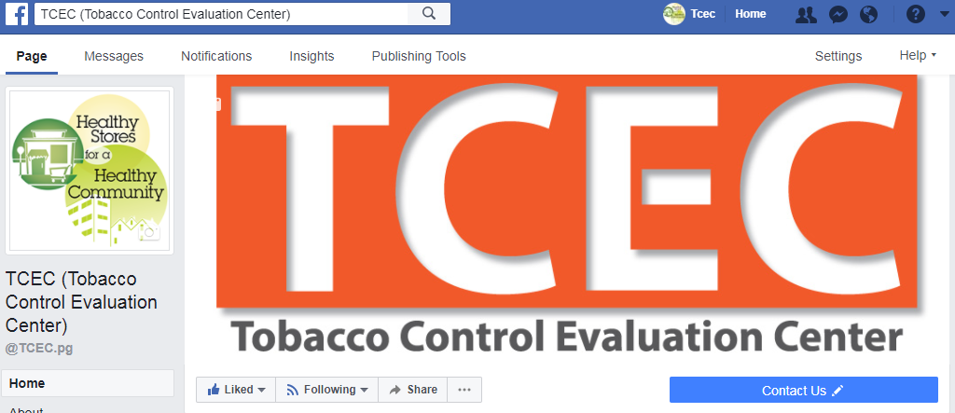
- Select “Insights” at the top of the Page 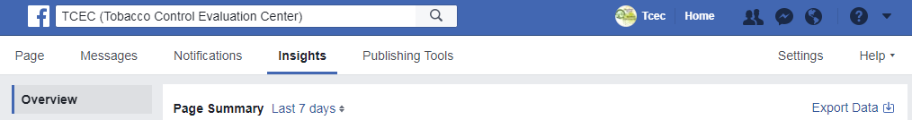
The Insights tab displays an overview (“Page Summary”) of key metrics such as Page Views (the number of time a Page has been viewed), Reach (the number of people who saw any of your posts), and Post Engagements (the number of times people have engaged with your posts through likes, comments, shares, and more), as well as the percentage change from the previous period.

- Select “Export Data”
This will open a dialogue box that allows you to customize the downloadable data report.
- Select desired Date Range, Data Type, and File Format.
- Page data will provide data for the overall likes and engagement with the page itself.
- Post data will provide data for each of the individual posts within the chosen Date Range.
- Video data will only provide metrics for videos posted during the chosen Date Range.

- Select the drop-down menu under “Layout” to refine the data.

Facebook will download all key metrics by default; to only download the data that is most relevant, select “Edit All Page Post Data” from the Layout drop-down menu.
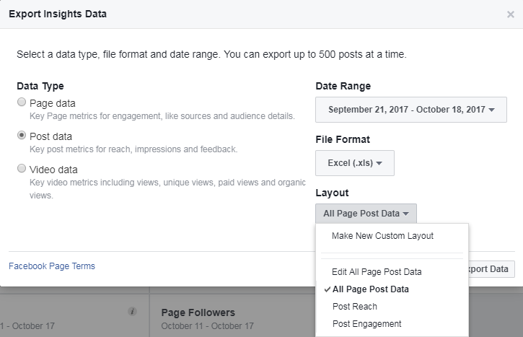

This will open a list of key metrics for post data, which can be rearranged, removed or separated into a new Excel sheet. 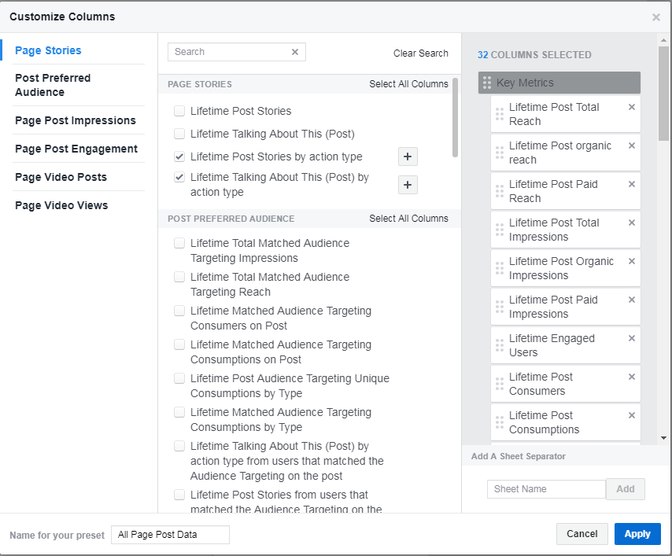
- Lifetime Post Reach is the number of unique users your Page post was served to.
- Lifetime Post Impressions is the total count of impressions of your Page post.
- Lifetime Engaged Users is the number of unique people who engaged in certain ways with your Page post; for example, by commenting on, liking, sharing, or clicking upon particular elements of the post.
- Lifetime Post Consumers is the number of unique users who clicked anywhere in your post.
- Lifetime Post Consumptions is the total count of clicks anywhere in your post.
Note: Most metrics are automatically broken down into “Paid” and “Organic” (unpaid) results.

- Select “Export Data” to download the desired file type.
The data as it appears in Excel will look something like this: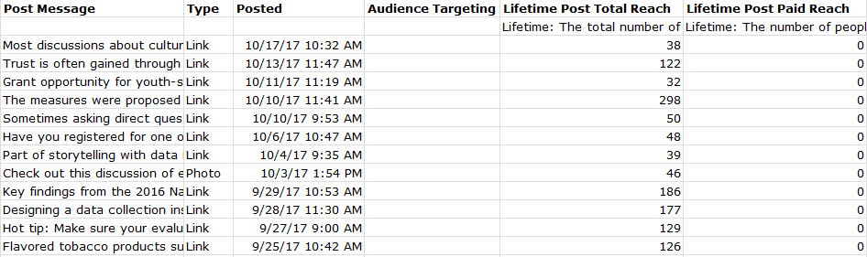
Feel free to click around the various report options to get the information that matters most to the project’s social media campaign.

Sample Write-Up of “Other” Evaluation Activities: Paid Social Media
To summarize the findings of your paid social media activities, quantify the number of paid social media posts (ads/“Boosted” posts on Facebook) and indicate the frequency, timing and type of post (when posted, how long each ad ran for, and if it was a link, photo or video post). Indicate if there was a target audience included, and what it was. Explain the results, including how many Facebook users saw the ad (Facebook distinguishes “total” views from “unique” views; the number of users who saw the ad without counting multiple views by the same person), and how many engaged with it (including reactions, comments, or link clicks on the post).
Below are three examples of what that might look like. The first gives an example of a successful paid social media campaign. The second gives an idea of how to summarize efforts that have not yielded as much reach or engagement. These are typical reach numbers for a paid or boosted post, depending on the budget and length of time that it runs. Engagement depends on how well the audience is targeted, as well as the content of the post itself. The third sample write-up summarizes social media activity for a page that has not paid for any posts and has only “organic,” or unpaid, audience reach.
Sample Write-Up #1
Social media efforts were successful in generating engagement with users in our community. Using Facebook Ads, we ran five Boosted Posts from the Coalition’s Facebook page. Each post ran for two weeks at a cost of $15 per post (with a total cost of $75 across the entire campaign). Three of the posts were customized with a target audience to reach users within the county, between the ages of 18 and 65, and who had interests in Health & Wellness. These posts received the most reach and user engagement.
As a result of these ad campaigns, we reached a total of 16,200 unique users, with a total engagement of 302 across all five posts.
In the next six months, staff will work with the Coalition to create more video posts, as the video ad received the most reach as well as the most user engagement. We will also connect with other local organizations to collaborate on future posts, and customize all future posts to targeted groups to reach the most relevant audience possible.
Sample Write-Up #2
Our efforts to reach Facebook users through a paid social media campaign yielded partial results. Staff ran three Boosted Posts from the LLA’s Facebook page. The first two paid posts ran for a week each at a cost of $7 per post, and did not utilize any audience targeting. The third paid post ran for two weeks at a cost of $14, and was targeted to reach users in the region who followed pages similar to the LLA’s page.
As a result of these campaigns, we reached a total of 900 unique users, with a total engagement of 127 across all three posts. The targeted ad received the most reach as well as the most engagement.
In the next six months, staff will collaborate with the youth and adult coalitions to develop more effective messaging for social media users in the community, and will run paid ads more frequently. We will also utilize custom audiences for more future social media posts.

Sample Write-Up #3
Staff worked throughout the last funding period to reach Facebook users with unpaid social media posts, with minimal success. We posted twelve unpaid posts total to the project’s Facebook page during this time; eleven of the posts were links, and the final post was a photo.
As a result, our organic reach was 1,291 unique users total from all twelve posts. Clicks, reactions and comments on posts were limited, with a total engagement of 36 across all posts. Because the posts were unpaid and did not utilize any audience targeting, there is no way to know if users who saw the posts were part of the population we intended to reach.
In the next six months, staff will explore a targeted, paid social media campaign to reach our desired audience and generate more effective social media messaging.

